MASTER OF COMPUTER APPLICATION (MCA)

PROJECT GUIDELINES

Shaheed Bhagat Singh State Technical Campus
NH-95, Moga Road
Ferozepur (Punjab)-152004
CONTENTS

I. PROJECT REPORT PREPARATION

II. CERTIFICATE OF ORIGINALITY FROM THE SUPERVISOR
III. PROJECT REPORT SUBMISSION
A) IMPORTANT POINTS OF PROJECT REPORT

B) FORMAT OF PROJECT REPORT

I. PROJECT REPORT PREPARATION

Front Page

The Title of Project

A Project Submitted
in Partial Fulfillment of the Requirements
for the Degree of

Master of Computer Application

by

Student Name



DEPARTMENT OF COMPUTER APPLICATIONS
Shaheed Bhagat Singh State Technical Campus
NH-95, Moga Road
Ferozepur (Punjab)-152004

Month Name, Year
1. A Project Report should include the following items:

➢ Introduction

➢ Objectives

➢ Tools/Environment Used

➢ Analysis Document (This should include SRS i.e., Software Requirement Specification in proper structure based on Software Engineering concepts, E-R diagrams/Class diagrams/any related diagrams (if the former are not applicable), Data flow diagrams/other similar diagrams (if the former is not applicable), Data dictionary)
➢ Design Document (Modularization details, Data integrity & constraints including database design, Procedural design, and User interface design).
➢ Testing (Test case designs are to be included separately for Unit testing, Integration testing, System testing; Reports of the outcome of Unit testing, Integration testing, System testing are to be included separately. Also, details of debugging and code improvement are to be included.)
➢ Input and Output Screens.

➢ Implementation of Security for the Software developed (In case, you have set up a User Name and Password for your software, you should ensure the security of User Name and Password during transmission to server)
➢ Limitations of the Project

➢ Future Application of the Project

➢ Bibliography

Students need not to attach the code in their project reports. The project report should be hard/spiral bound; should consist of a contents page; all pages of report should be numbered; content should be well organized in a meaningful manner; paragraph alignment should be maintained, printouts of text & screen layouts should be original and should not be Xeroxed). In the scheduling Viva-voce date, students have to submit the softcopy and hard copy of the project separately.

2. Certificate of Originality from the Supervisor.

3. The Project Report may be about 50 to 80 double spaced A-4 size typed pages

(Excluding program code).
II. CERTIFICATE OF ORIGINALITY FROM THE SUPERVISOR

CERTIFICATE

This is to certify that the project report entitled...................................................

………………………………………………………………………………………………….. submitted to Department of Computer Applications, Shaheed Bhagat Singh State Technical Campus, Ferozepur (affiliated to Punjab Technical University, Jalandhar) in partial fulfillment of the requirement for the award of the degree of MASTER OF COMPUTER APPLICATION (MCA), is an original work carried out by Mr./ Ms. ............................ …………………………………………Roll. No.:............................ under the supervision of Mr./ Ms.............................................................

The matter embodied in this project is a genuine work done by the student and has not been submitted either to this University or to any other University / Institute for the fulfillment of the requirement of any course of study.

Signature of the student Signature of the supervisor
Name: Name: Address: Address:

Roll. No.:
Seal

III. PROJECT REPORT SUBMISSION

The students have to make three copies of his completed Project Report and submit one copy of it to the department and another one to the library. One copy of the report will be with him/her for reference.

A. IMPORTANT POINTS OF PROJECT REPORT

1. Ensure that it contains the following:

➢ Project Proposal.

➢ Certificate of Originality from the Supervisor.

➢ All signatures should be accompanied by the date of signature. It should include all items mentioned in Section I.
2. If any project report is received in the absence of the items listed above, it will be rejected and returned to students for compliance. Also, violation of Project Guidelines may lead to rejection of the Project.
3. Only hard bound original copy of the project report is to be submitted to the University. One copy of same Project Report is to be retained with the student and the student is supposed to carry his/her copy while appearing for viva voce.
4. Xerox copy of the project report is not acceptable.

5. If the title of the Project differs from the title mentioned in the Project Proposal/synopsis, the Project Report will be rejected and will be returned back to the student.

B. FORMAT OF REPORT
Report Size
- The maximum number of pages of the Report should be preferably between 60 -80 pages.
Paper Size
- The standard size of paper of a Report is A4 paper.
Printing
- It is suggested that the report be printed on one side of the paper.

Electronic Material
- CDs and DVDs should be included in the report. They have to be given in a closed pocket in the inside of the back cover page of the report. The label on electronic material indicates the name of the student, the date of submission
Page Numbering
- Page numbers for the prefacing materials of the report should be in small Roman numerals and centered at the bottom of the pages.
- Page numbers for the body of the report should be in Arabic numerals and should be centered at the bottom of the pages. The pagination should start with the first page of Chapter 1 and should continue throughout the text (including tables, figures, and appendices)
Binding
- The report submitted for examination has to be hardbound.

The guidelines for the text of the report are given below. The students are advised to strictly follow these guidelines.
Font
- The preferred font size of the text in the report is 12 point. The minimum font size of materials within a table or a figure can be 8 point.
- The preferred font type is Times New Roman.

Margins
- A margin of 3.75 cm (1½ inch) is to be given on the binding edge while on the other sides it is to be 2.5 cm (1 inch). The text of the report, including headings, figures, tables, and notes, but excluding page numbers, must be accommodated within the page area.
Line Spacing
- The line spacing in the main text must be one-and-a-half. Single line spacing should be given for synopsis, undertaking, acknowledgement, figure captions, table titles, figure legends, footnotes, and references.
- Equations, tables, figures, and quotations should be set off from the main text with adequate space. The sample examples for tables and figures are shown below:
Table 1: Example of Table caption
Heading 1 | Heading 2 | Heading 3 | Heading 4

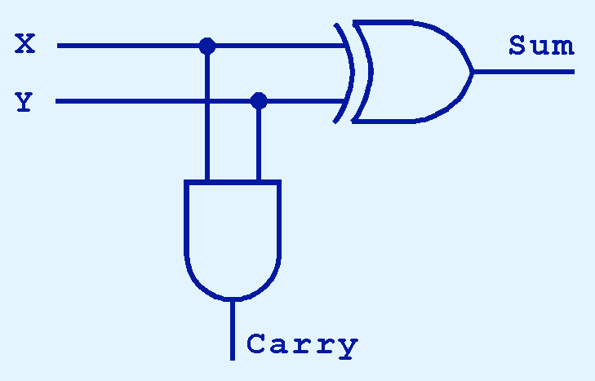
Figure 1: A half adder
- Two consecutive paragraphs should be separated by double line spacing.

* * *

